**VSG PADDY SEEDER MACHINE**

The VSG group invented the VSG paddy seeder machine in Jaffna in 2022.

This machine plants paddy seeds within accurate space and straight line and reduces manpower/energy and planting will be quick and easy.

Advantages of this machine

* Get high and optimum output /yield
* Weed can be easily controlled
* Interpolation is easy
* Weeds can be easily controlled
* 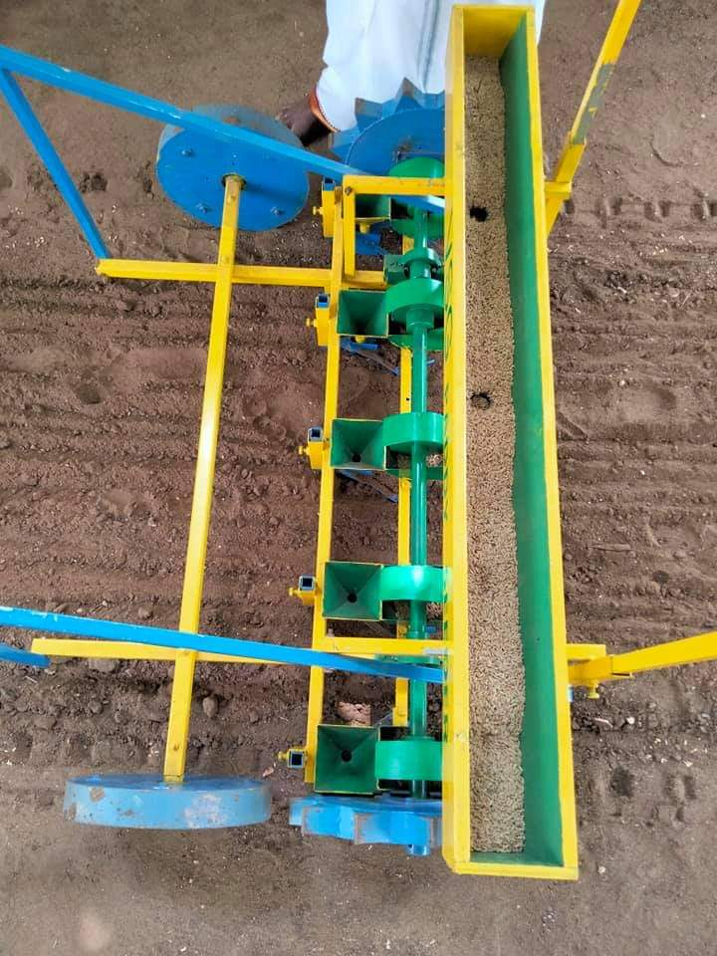Small amount of seed is sufficient and can be reduced seeds wastage.

