**LAWULU Milkshake**

**B.M.Sevwandi**

**Department of Agri business management**

**Faculty of Agricultural Sciences**

**Sabaragamuwa university of Sri Lanka**

[**sevwandi1998@gmail.com**](mailto:sevwandi1998@gmail.com)

Egg fruit is not only can be found in Sri Lanka but also in Central America, South Mexico, Caribbean region and etc. Beta carotene is highly consisted in the flesh. Inside the body this flesh will convert into vitamin A, increase the immunity of the body, by providing P and Ca it helps to strengthen the bones, teeth, by Fe hemoglobin is produced. In Sri Lanka we won’t use these egg fruits effectively. But instead we can use these egg fruits and produce various products.

This vedio is about the preparation of lawulu milkshake. First the egg fruit was washed well and peeled out. Next it was cut into pieces. For 100g of flesh, 1l of fresh milk, 50g of sugar and 1 table spoon of vanilla were added. This mixture was blended. At last ice cubes were added to the mixture.

Not only Lawulu milkshake but also lawulu milk toffee, lawulu roti, lawulu pittu, lawulu pinatu and lawulu curry like many products can be introduced to the market.

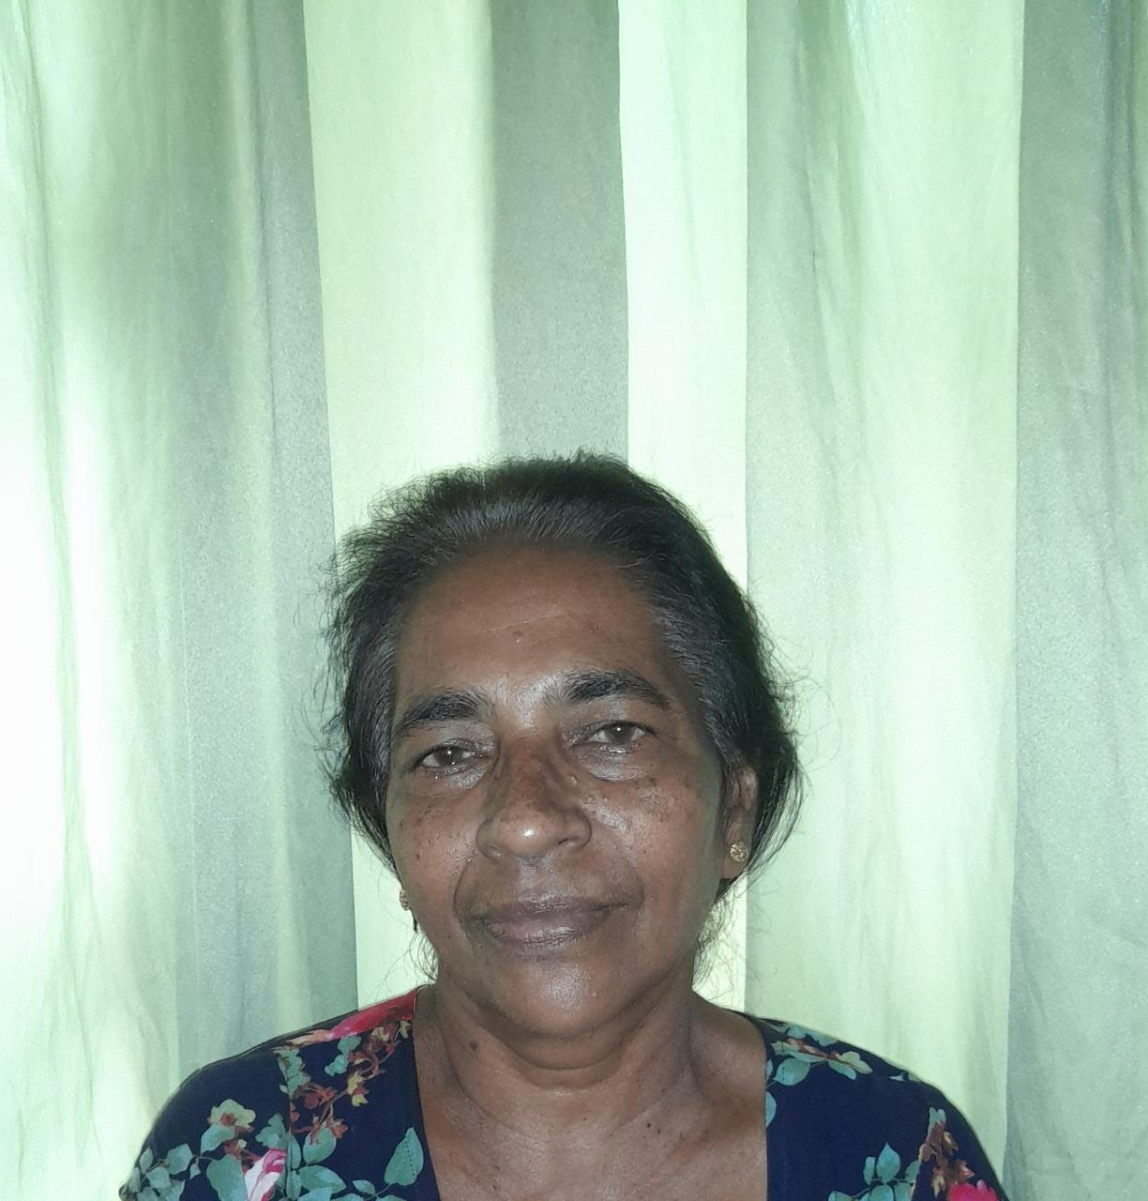

B.M.Sevwandi

Department of Agri business management

Faculty of Agricultural Sciences

S.K. Ekanayake

03, N.H.S. Kotuwegedara, Matale.

