MANAGING THE RISING POULTRY FEED COSTS THROUGH INSECT BIO-MASS CONVERSION OF DOMESTIC FOOD WASTE

WHD Maveesha1, KAC Premalal2

**1** Department of Agribusiness Management, Faculty of Agricultural Sciences, Sabaragamuwa University of Sri Lanka,

2 Dulanmahara Farm, Bokundara, Piliyandala

dakshinimaveesha@gmail.com

**Abstract**

Small-holding poultry farmers in Sri Lanka have increasing challenges in balancing the rising cost of feed against the market value of eggs. Current research uses fly larvae for bio-mass conversion and creating a high-quality, nutritious animal feed. The subject farmer uses a similar but innovative idea of farming larvae using leftover food in his neighbourhood. Domestic food waste, collected from local houses, is left partially covered in plastic or metal bins for 3-4 days. Flies access the decomposing food, lay eggs, and larvae emerge in a few days through holes drilled around the bottom of each bin. Chickens farmed under a semi-intensive farming method are released near the bins to pick the larvae emerging from the holes. The nutritional value of fly larvae is more consistent than that of mixed domestic food waste. The farmer observes that chicken exercise more when picking larvae, keeping them lean, resulting in more egg production. This process also gives householders a regular and dependable waste disposal method. In 3 to 4 days, the larvae metabolise the food waste and produce proteins and fats commonly found in poultry feed. In this qualitative experiment, the farmer is showing the efficient conversion of domestic food waste into poultry feed at virtually zero cost. In this qualitative study, the farmer cannot quantify the non-zero cost avoidance, because of the lack of detailed accounts. A scientific study of the quality and food safety of the eggs produced has not been done. Further laboratory analysis of the larvae and the eggs produced for (a) nutritional content, and (b) the prevalence of phosphates and heavy metals is warranted. This analysis can lead to a better selection of food waste by the farmer for larvae production.

**Keywords:** **alternative feed, bio-mass conversion, food-waste recycling,** **larvae feed, poultry farming**

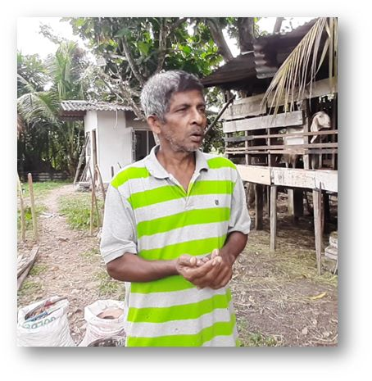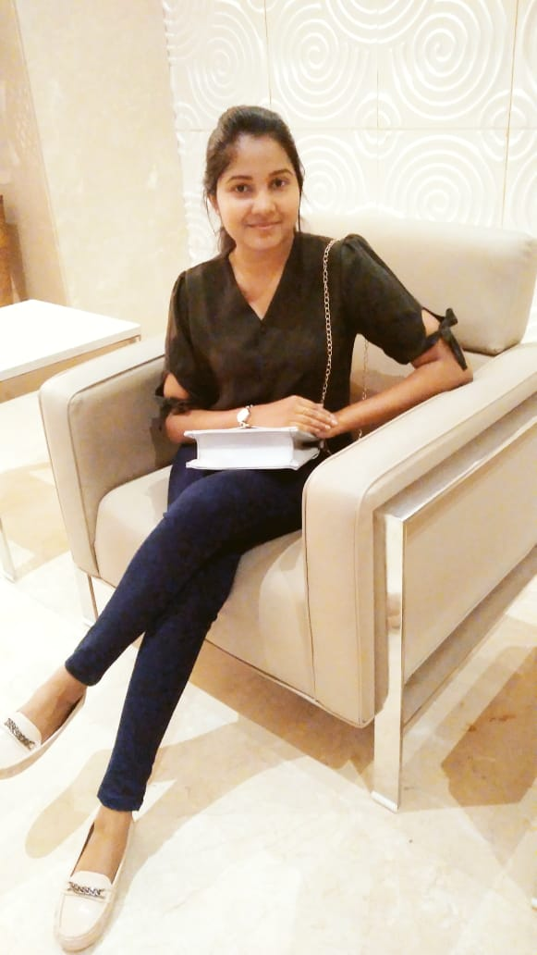

WHD Maveesha1

Department of Agribusiness Management,

Faculty of Agricultural Sciences,

Sabaragamuwa University of Sri Lanka.

KAC Premalal2

Dulanmahara Farm,

Bokundara,

Piliyandala.