**AQUAPONICS CULTIVATION**

**Author 1 - Sugandi Gunasekara**

*Sabaragamuwa University of Sri Lanka,*

*Faculty of Agricultural Sciences,*

*Department of Agri Business Management.*

[psmsgunasekara@std.agri.sab.ac.lk](mailto:psmsgunasekara@std.agri.sab.ac.lk)

**Author 2 – Heshan Fernando**

*(CEng, BEng, (Hons)UK).*

*Managing Director.*

*Hilldale Retreat (Pvt) Ltd.*

*Aquaponics Sri Lanka.*

[aquaponicssrilanka@gmail.com](mailto:aquaponicssrilanka@gmail.com)

**Abstract** Many farmers in the world are turning to organic farming because chemical fertilizers are harmful to the environment and human consumption. Despite the abundance of water in Sri Lanka, crops are destroyed due to a lack of water during dry weather and low rainfall. Aquaponics provides a proper answer to these problems. Another reason is the rapidly growing population worldwide. As a food industry, we need to feed everyone. But the resources are limited. Specially water and soil. The research was conducted at the Hilldale Retreat Hotel, Kudo Oya, Nuwara Eliya, and its managing director, Mr. Heshan Fernando, assisted in the research development. Hilldale Retreat Hotel uses this aquaponics method to grow its own vegetables and fruits for guests. Aquaponics is a 100% organic farming method. Because the same water is used to grow fish and plants, if fertilizers are applied to the crops, the fish will die. Simply put, aquaponics is a combination of aquaculture and hydroponics. Fish are grown in aquaculture, and hydroponics grows crops using water-based nutrient solutions without soil. Nitrogen is the most essential nutrient for growing plants. Fish waste is high in nitrogen. The main finding of this research is to grow 100% organic crops using fish and go with the modern world to develop agriculture. Because this is an agricultural cultivation method that is in line with current technological development and is organic, its commercial value is enormous. So, starting as a self-employed person and using this aquaponics farming method will surely help reach a bigger commercial market.

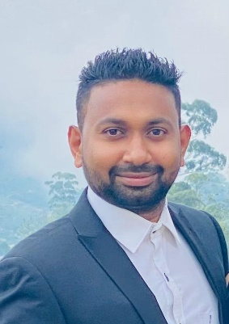**Keywords** Aquaponics Fish Nitrogen Organic farming Water

**Heshan Fernando**

(CEng, BEng, (Hons)UK).

Managing Director.

Hilldale Retreat (Pvt) Ltd.

Aquaponics Sri Lanka.

**Sugandi Gunasekara**

Sabaragamuwa University of Sri Lanka,

Faculty of Agricultural Sciences,

Department of Agribusiness Management.