**LIQUID FERTILIZER MIXTURE INNOVATION BY A RURAL FARMER**

**K.K.Biyagama**

18AGA1605

Faculty of Agricultural Sciences

Sabaragamuwa University of Sri Lanka

[kalanibiyagama@gmail.com](mailto:kalanibiyagama@gmail.com)

Co-author: Mr.H.W.Gunawardhana

Abstract

There is a large fertilizer shortage in our country. Due to this, farmers face many problems. There is no enough successful fertilizer available in the market. As a result of that, overall food production in Sri Lanka in the last harvest season was lower than last year. This problem can be solve using innovations. Some farmers try to use organic fertilizer but the quality and quantity of the harvest is not in proper condition. Therefore some farmers do experiments related to new organic fertilizer production.

This video is about a farmer who produce a new liquid fertilizer mixture on his own method. He lives in Kehelovitigma area. He use Gliricidia, Wild sun flower like Nitrogen rich plant leaves, cow dung, sugar, water as ingredients. He mix them with water and keep for few days for fermentation. After that filter and bottle them to send to the market. Some of his experiments are ongoing to improve this fertilizer.

He has quality assurance certificate issued by Ministry of Agriculture and a fertilizer analysis report issued by Bamer and Bruce (pvt) LTD. 200ml of this fertilizer solution can be use for 16l knapsack sprayer tank by dilution. The 1l of fertilizer bottle can be use to make 5 knapsack tanks. Its efficiency is high. Cost is low. The quality and growth rate of the plant which use this fertilizer is good. This is a good, effective and Nitrogen rich fertilizer but he don’t have good market due to lack of publication. This fertilizer is a good subsidies for current fertilizer problem for farmers.

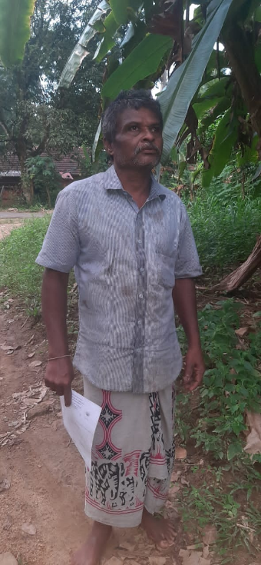

Ms. K.K.Biyagama Mr.H.W.Gunawardhana

18AGA 1605