**LAWULU Milkshake**

**B.M.Sevwandi**

**Department of Agri business management**

**Faculty of Agricultural Sciences**

**Sabaragamuwa university of Sri Lanka**

[**sevwandi1998@gmail.com**](mailto:sevwandi1998@gmail.com)

Egg fruits are medium sized. The skin of this fruit is smooth, thin, easily punctured, glossy and waxy while the flesh is dry, bright yellow coloured, creamy and thick. Egg fruit is not only can be found in Sri Lanka but also in Central America, South Mexico, Caribbean region and etc. Beta carotene is highly consisted in the flesh. Inside the body this flesh will convert into vitamin A, increase the immunity of the body, by providing Phosphorus and Calcium it helps to strengthen the bones, teeth and by Ferus, hemoglobin is produced. In Sri Lanka we would not use these egg fruits effectively. But instead we can use these egg fruits and produce various products.

This video is about the preparation of lawulu milkshake. First the egg fruit was washed well and peeled out. Next it was cut into pieces. For 100 grams of flesh, 1 liter of fresh milk, 50 grams of sugar and 1 table spoon of vanilla were added. Then ice cubes were added and the mixture was blended. At last ice cubes were added again to the lawulu milkshake before serving.

Not only Lawulu milkshake but also lawulu milk toffee, lawulu roti, lawulu pittu, lawulu pinatu and lawulu curry like many products can be introduced to the market. Specially the health conscious people can be the target group and according to the current situation, in both local and global market Lawulu products and specially Lawulu milkshake will hold a huge opportunity.

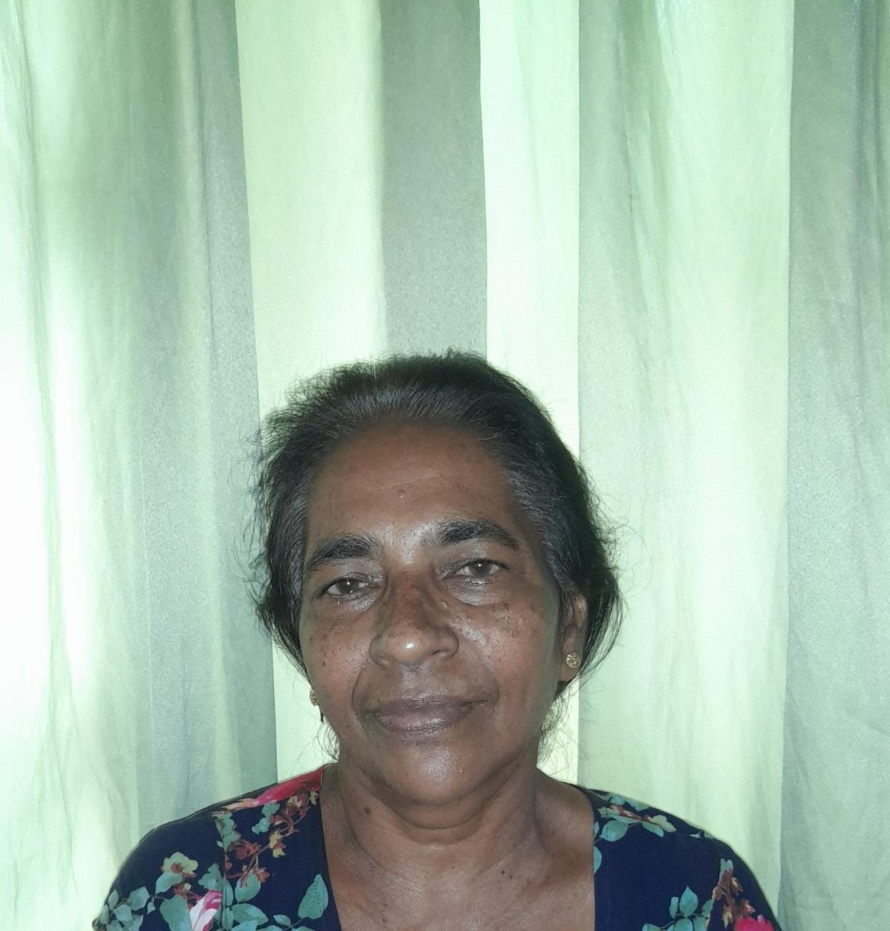



S.K. Ekanayake

03, N.H.S. Kotuwegedara, Matale.

B.M.Sevwandi

Department of Agri business management

Faculty of Agricultural Sciences