Successful manioc cultivation in home gardening

Home gardening is normally done not only to earn income or get a profit but also for pleasure and happiness of the board life. A very big land is not needed to do home gardening. By applying sustainable management of the land, it can be done easily in a small land area. In this video, I mainly focus on manioc cultivation and how it can be improved for sustainable usage. The main objective of this video is to communicate the information and knowledge use in my home town to the people and farmers who are interested in home gardening and manioc cultivation in Behihuloya area. The farmer who was joined with me to present information was Mr. Jayawardana, a retired Engineer. He has taken knowledge of home gardening through training programs conducted by the Agricultural Department at Labuduwa, through agriculture-related TV programs, books and newspapers. I observed his home garden and collect much information about home gardening. He has cultivated manioc in his garden using a new method that is practiced by himself. He has planted them in gunny or Polyethene bags. The advantages of this method are the yield can be protected from rats and also when taking the yield out, cracks in the roots are minimum. And also, a single root can be taken to daily or one-day consumption. Through this video, the farmers can be learned how to prepare a gunny bag for manioc cultivation, what is the relevant soil media, how to choose a good manioc stick for cultivation, how to cultivate manioc sticks and how to get a single root for one-day consumption very clearly.

Key words- gunny bag, home gardening, manioc, one-day consumption, small land area, sustainable

Author-



S.T.Abeysinghe

Undergraduate

Department of ExportAgriculture

Faculty of Agricultural Sciences.

Co- authors-

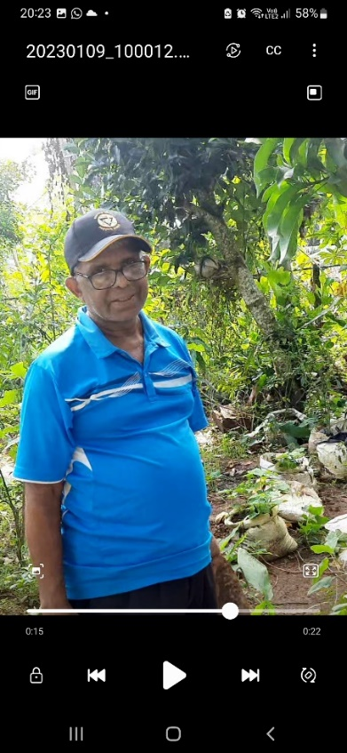

Mr. Jayawardana

Former Engineer in Water Board Wackwella.