STALE BREAD TO FACILITATE LOCAL ENTREPRENEURIAL GROWTH IN THE FOOD INDUSTRY

WHD Maveesha1, MSS Peris2

**1** Department of Agribusiness Management, Faculty of Agricultural Sciences, Sabaragamuwa University of Sri Lanka,

2 Moratuwa, Molpe

dakshinimaveesha@gmail.com

**Abstract**

Developing self-employment in the food business sector is critical in achieving sustainable economic growth and alleviating poverty in Sri Lanka. This study aims to illustrate a new method for becoming a self-employed entrepreneur by utilising available opportunities for small investors in the food business sector and to showcase the importance of starting new ventures relating to rural self-employment. An interview with the entrepreneur and direct observations were used to gather information. The self-employed woman working in small-scale food production in Molpe in the Western Province, Sri Lanka, is also a part-time seamstress. The results show that innovative thinking in the food production sector can create a successful self-employer by cost-effectively using available resources. Household income was severely reduced for families in rural areas during the COVID-19 pandemic, and the prices of branded biscuits increased due to inflation. Using these worsening conditions as an opportunity, a small business was started by this woman using stale bread returned from pastry shops to fill a gap in the local market for tasty biscuits at affordable prices. The product contains fried, crispy small bread pieces with butter, milk, sugar, and caramel sauce. This product contains no other artificial essences, food colourings or preservatives. As a result, this product has become very popular as a substitute for biscuits and has managed to meet the high demand for biscuits in this village. Recycling usable waste products is a novel way of developing a small-scale business while responding to severe economic conditions at the same time. Further research on the nutritional value of the biscuits produced and customer satisfaction surveys can help scale up production and diversify the business to other similar products where economical.

**Keywords – food business, self-employment, stale bread, ventures**

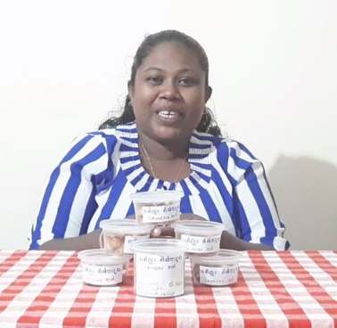

MSS Peris2

Moratuwa, Molpe

WHD Maveesha1

Department of Agribusiness Management,

Faculty of Agricultural Sciences,

Sabaragamuwa University of Sri Lanka.